PURPOSE:

The Government of India has announced a lockdown period to reduce the community spread of the COVID-19 pandemic. To assist the government, an initiative by Predulive Edutech Foundation (Non-Profit Organization) & Pi Drones (Tecrient Space Pvt. Ltd.) startup of IIT Kanpur was taken to enhance the capabilities of Indian Homeland Security, Uttar Pradesh Disaster Forces and Police Departments.

BACKGROUND:

* Implementation of the project in all cities
* Providing Drones, Pilots, & Software Tech
* Only Police Authority will have access to Data After data delivery to authorities, it will be deleted from application servers
* Being a Section 8 (non-profit) company, we are trying to seek Corporate Social Responsibility contributions to cover U.P. DRRF project expenses
* On approval, a commercial proposal (covering very basic costs) will be submitted
* Assessment for areas to be monitored
* Police will cover the expenses of Drone Pilots
* Approval for required funds for specific duration
* Police will provide the transportation, Food, PPE Kits, and Police personnel to assist Drone pilots for the operations
* Police will take the necessary actions based on the information gathered from Drones to ensure lockdown
* Safety & security to Drone Pilots

ROLE OF PI-DRONES:

ROLE OF LOCAL AUTHORITIES:

Predulive Edutech Foundation (Non-Profit Organization) try to support security forces to monitor the National Lockdown efficiently, with minimal police personnel exposure to COVID19 risk with the collaboration of local Drones operators & Pi Drones startup of IIT Kanpur. Pi Drones Constitutes ready-to-deploy drones and highly trained pilots, with experience of flying & managing country wide Drone operation.

SERVICES OFFERED:

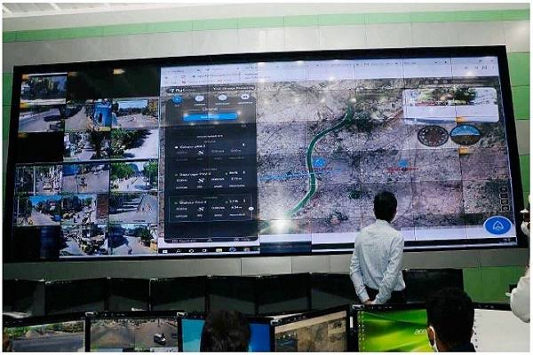

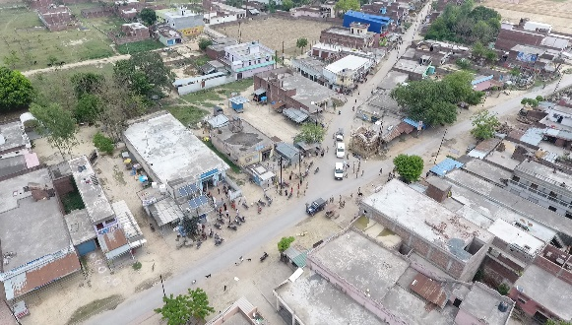

**Crowd Monitoring**

Pilots covering 700 m radius from their rooftops.

Pilots travel with Sp. Inspector to cover larger areas.

OPERATIONAL PLAN:

Crowd Monitoring

Real-time video streaming

Drones send a live feed data to control room.

City-wide Surveillance

* Free Demo can be performed on first Day to District Authorities.
* After discussion with Police authorities, would decide number of drones to be deployed in District.
* Police will give a fund approval to cover the expenses of only the Drone operators.
* After approval within 24 hours Predulive Edutech Foundation would deploy the solutions on ground.

EXECUTION OF THE PROJECT:

Depending on the number of hotspots and positive COVID cases. Some cities/district have been finalized to deploy Drones for surveillance & monitoring:

**Kanpur, Lucknow, Agra, Ghaziabad, Gautam Buddh Nagar (Noida), Gorakhpur, Basti, Sitapur, Sant Kabir Nagar, Varanasi, Raebareli, Moradabad, Prayagraj, Meerut, Saharanpur.**

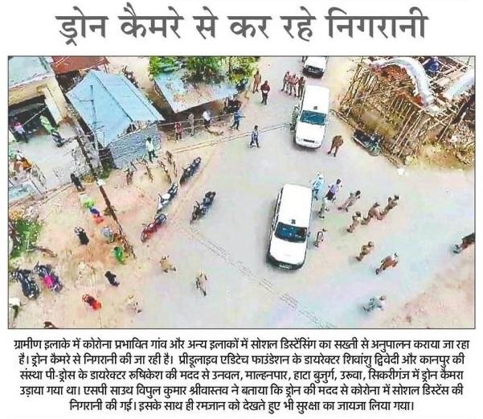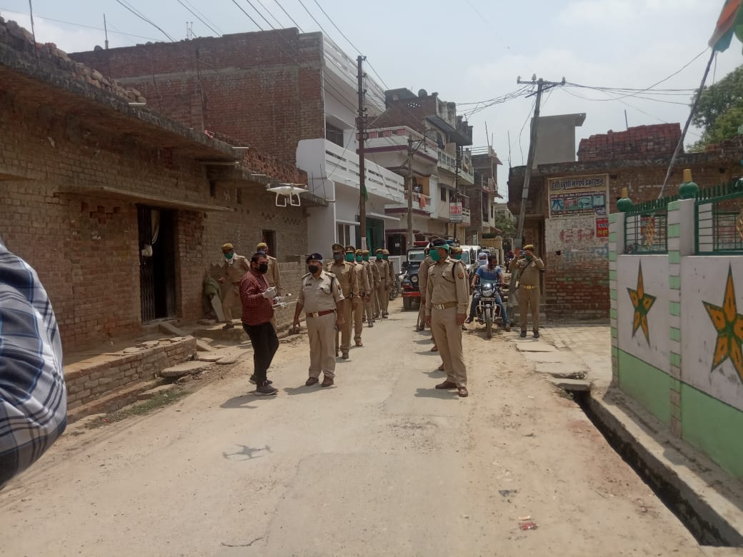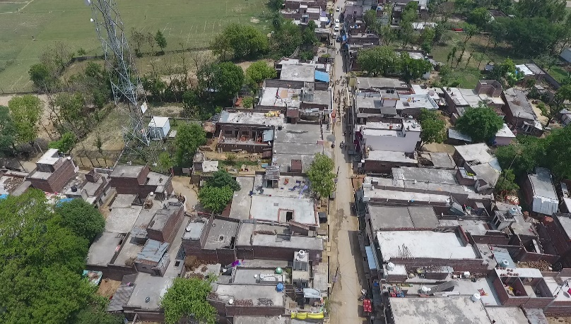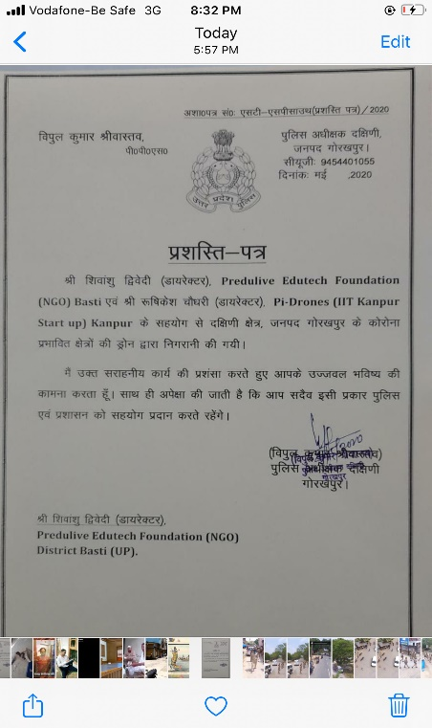

1. Surveillance & Monitoring with Drone in **Lucknow.**
2. Surveillance & Monitoring with Drone in **Gorakhpur.**

OUR OPERATIONAL AREAS:

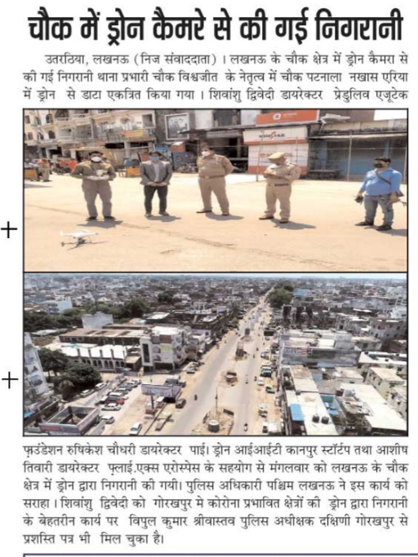

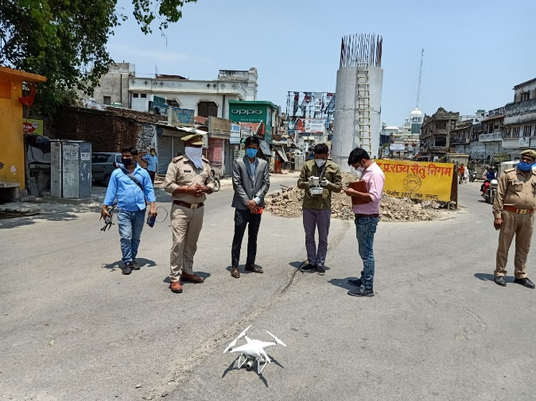

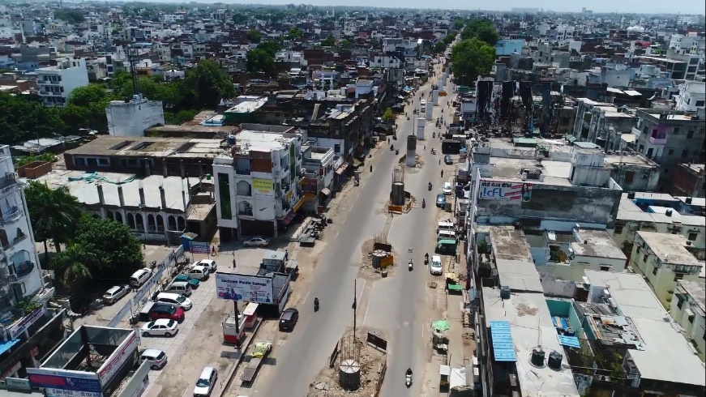

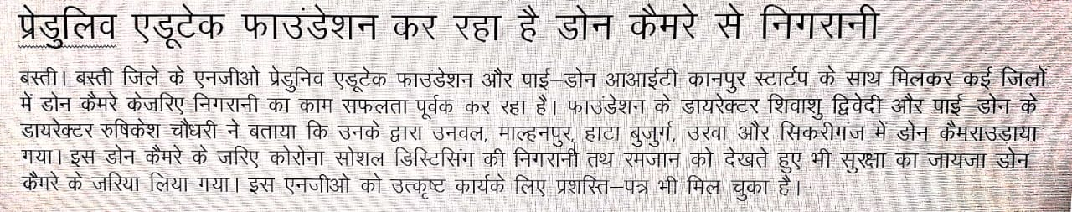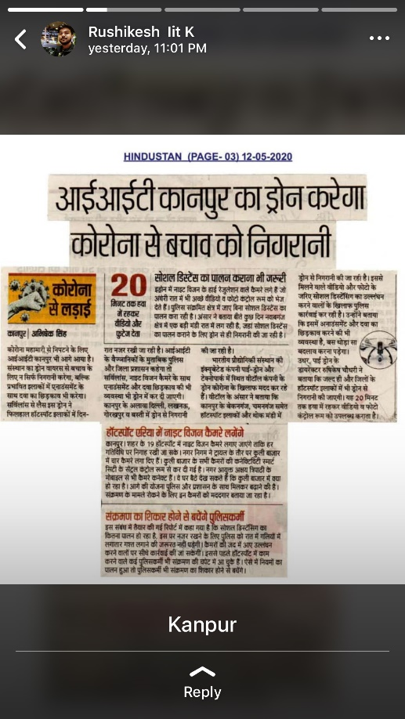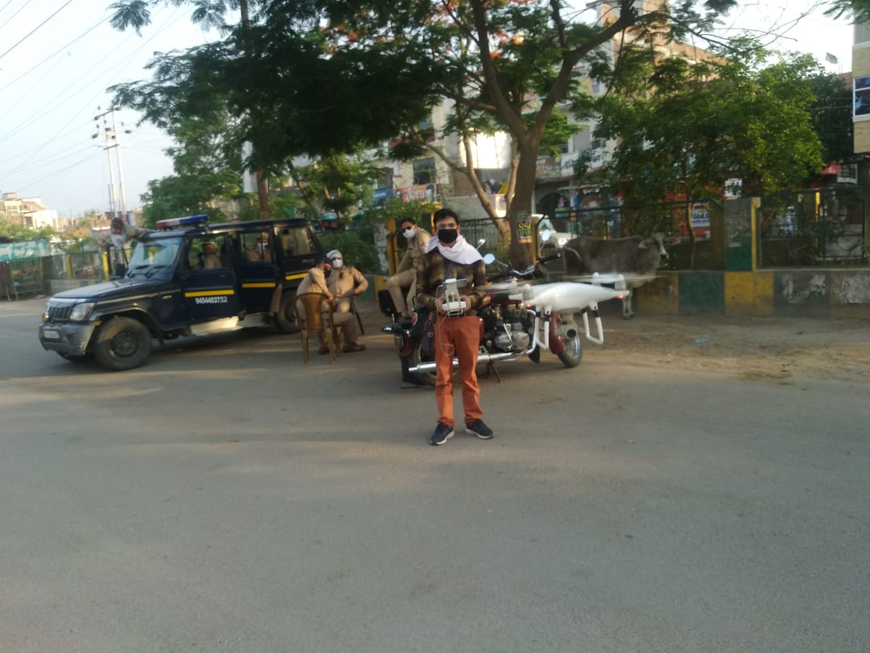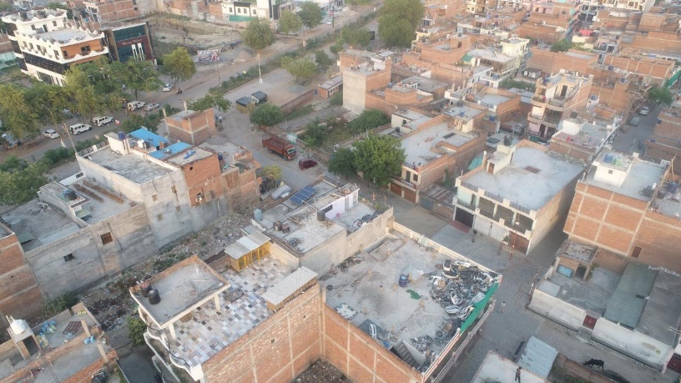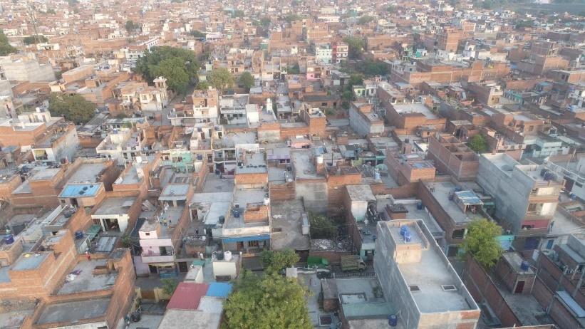

1. Surveillance & Monitoring with Drone in **Kanpur.**